//Double Linked List

#include<stdio.h>
#include<stdlib.h>
struct node
{
struct node *prev;
struct node *next;
int data;
};
struct node *head;
void insertion_beginning();
void insertion_last();
void insertion_specified();
void deletion_beginning();
void deletion_last();
void deletion_specified();
void display();
void search();
void main ()
{
int choice =0;
while(choice != 9)
{
printf("\n*********Main Menu*********\n");
printf("\nChoose one option from the following list ...\n");
printf("\n===============================================\n");
printf("\n1.Insert in begining\n2.Insert at last\n3.Insert at any random location\n4.Delete from Beginning\n5.Delete from last\n6.Delete the node after the given data\n7.Search\n8.Show\n9.Exit\n");
printf("\nEnter your choice?\n");
scanf("\n%d",&choice);
switch(choice)
{
case 1:
insertion_beginning();
break;
case 2:
insertion_last();
break;
case 3:
insertion_specified();
break;
case 4:
deletion_beginning();
break;
case 5:
deletion_last();
break;
case 6:
deletion_specified();
break;
case 7:
search();
break;
case 8:
display();
break;
case 9:
exit(0);
break;
default:
printf("Please enter valid choice..");
}
}
}
void insertion_beginning()
{
struct node *ptr;
int item;
ptr = (struct node *)malloc(sizeof(struct node));
if(ptr == NULL)
{
printf("\nOVERFLOW");
}
else
{
printf("\nEnter Item value");
scanf("%d",&item);

if(head==NULL)
{
ptr->next = NULL;
ptr->prev=NULL;
ptr->data=item;
head=ptr;
}
else
{
ptr->data=item;
ptr->prev=NULL;
ptr->next = head;
head->prev=ptr;
head=ptr;
}
printf("\nNode inserted\n");
}

}
void insertion_last()
{
struct node *ptr,*temp;
int item;
ptr = (struct node *) malloc(sizeof(struct node));
if(ptr == NULL)
{
printf("\nOVERFLOW");
}
else
{
printf("\nEnter value");
scanf("%d",&item);
ptr->data=item;
if(head == NULL)
{
ptr->next = NULL;
ptr->prev = NULL;
head = ptr;
}
else
{
temp = head;
while(temp->next!=NULL)
{
temp = temp->next;
}
temp->next = ptr;
ptr ->prev=temp;
ptr->next = NULL;
}

}
printf("\nnode inserted\n");
}
void insertion_specified()
{
struct node *ptr,*temp;
int item,loc,i;
ptr = (struct node *)malloc(sizeof(struct node));
if(ptr == NULL)
{
printf("\n OVERFLOW");
}
else
{
temp=head;
printf("Enter the location");
scanf("%d",&loc);
for(i=0;i<loc;i++)
{
temp = temp->next;
if(temp == NULL)
{
printf("\n There are less than %d elements", loc);
return;
}
}
printf("Enter value");
scanf("%d",&item);
ptr->data = item;
ptr->next = temp->next;
ptr ->prev = temp;
temp->next = ptr;
temp->next->prev=ptr;
printf("\nnode inserted\n");
}
}
void deletion_beginning()
{
struct node *ptr;
if(head == NULL)
{
printf("\n UNDERFLOW");
}
else if(head->next == NULL)
{
head = NULL;
free(head);
printf("\nnode deleted\n");
}
else
{
ptr = head;
head = head -> next;
head ->prev = NULL;
free(ptr);
printf("\nnode deleted\n");
}

}
void deletion_last()
{
struct node *ptr;
if(head == NULL)
{
printf("\n UNDERFLOW");
}
else if(head->next == NULL)
{
head = NULL;
free(head);
printf("\nnode deleted\n");
}
else
{
ptr = head;
if(ptr->next != NULL)
{
ptr = ptr -> next;
}
ptr ->prev -> next = NULL;
free(ptr);
printf("\nnode deleted\n");
}
}
void deletion_specified()
{
struct node *ptr, *temp;
int val;
printf("\n Enter the data after which the node is to be deleted : ");
scanf("%d", &val);
ptr = head;
while(ptr -> data != val)
ptr = ptr -> next;
if(ptr -> next == NULL)
{
printf("\nCan't delete\n");
}
else if(ptr -> next -> next == NULL)
{
ptr ->next = NULL;
}
else
{
temp = ptr -> next;
ptr -> next = temp -> next;
temp -> next ->prev = ptr;
free(temp);
printf("\nnode deleted\n");
}
}
void display()
{
struct node *ptr;
printf("\n printing values...\n");
ptr = head;
while(ptr != NULL)
{
printf("%d\n",ptr->data);
ptr=ptr->next;
}
}
void search()
{
struct node *ptr;
int item,i=0,flag;
ptr = head;
if(ptr == NULL)
{
printf("\nEmpty List\n");
}
else
{
printf("\nEnter item which you want to search?\n");
scanf("%d",&item);
while (ptr!=NULL)
{
if(ptr->data == item)
{
printf("\nitem found at location %d ",i+1);
flag=0;
break;
}
else
{
flag=1;
}
i++;
ptr = ptr -> next;
}
if(flag==1)
{
printf("\nItem not found\n");

}
}

OUTPUT

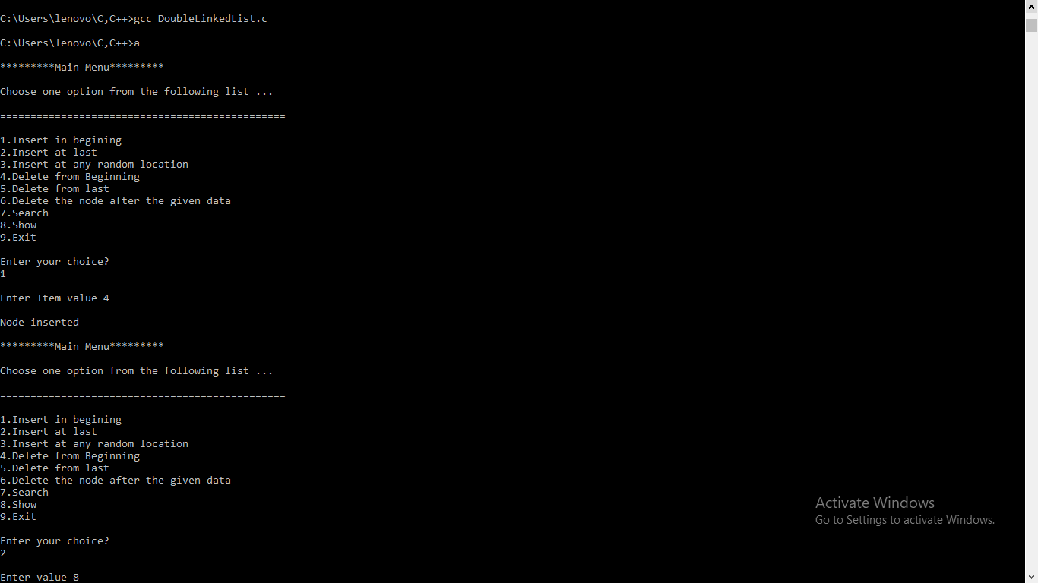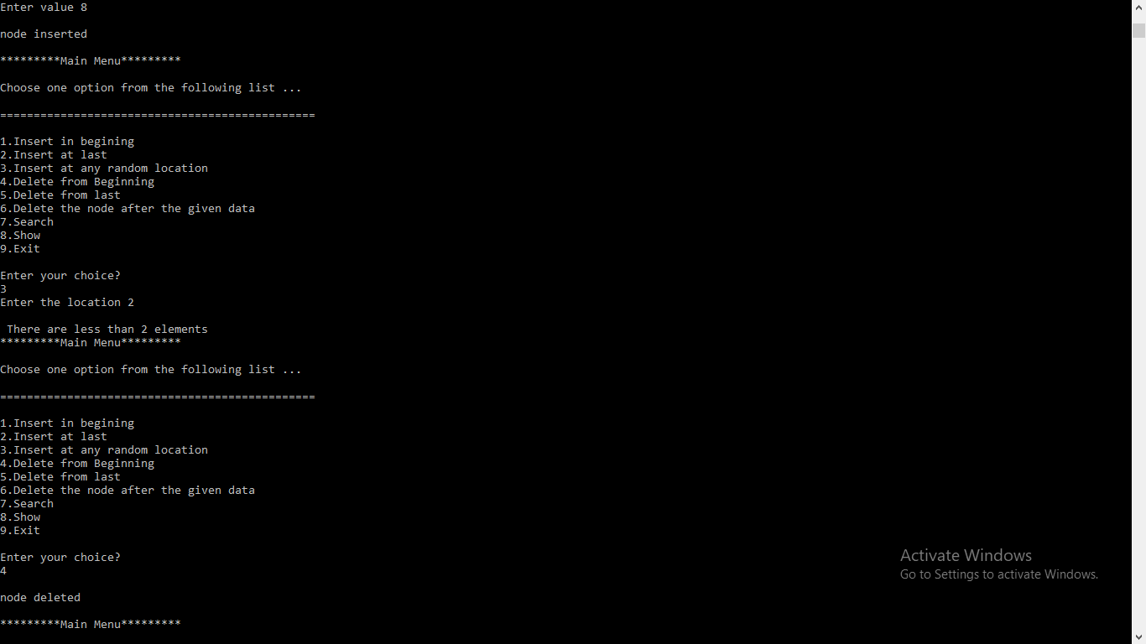
P.T.O

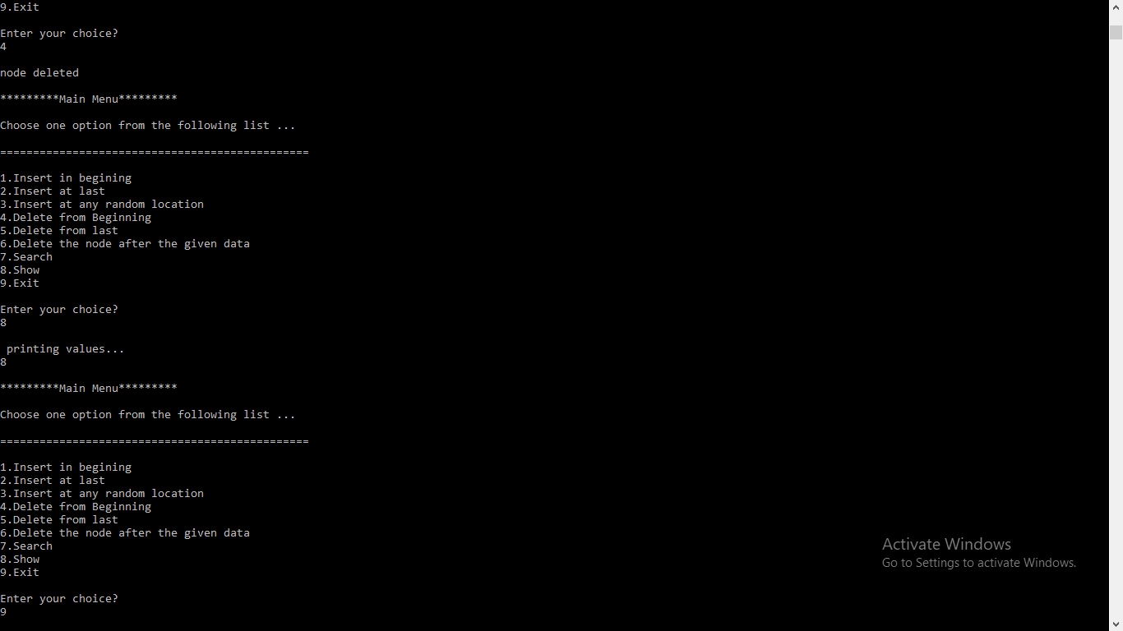

//Single Linked List

#include <stdio.h>
#include <stdlib.h>
struct node
{
int num;
struct node *nextptr;
}*stnode;
void createNodeList(int n);
void displayList();
int main()
{
int n;
printf("\n\n Linked List : To create and display Singly Linked List :\n");
printf("-------------------------------------------------------------\n");
printf(" Input the number of nodes : ");
scanf("%d", &n);
createNodeList(n);
printf("\n Data entered in the list : \n");
displayList();
return 0;
}
void createNodeList(int n)
{
struct node *fnNode, *tmp;
int num, i;
stnode = (struct node *)malloc(sizeof(struct node));
if(stnode == NULL)
{
printf(" Memory can not be allocated.");
}
else
{
printf(" Input data for node 1 : ");
scanf("%d", &num);
stnode->num = num;
stnode->nextptr = NULL;
tmp = stnode;

for(i=2; i<=n; i++)
{
fnNode = (struct node *)malloc(sizeof(struct node));
if(fnNode == NULL)
{
printf(" Memory can not be allocated.");
break;
}
else
{
printf(" Input data for node %d : ", i);
scanf(" %d", &num);
fnNode->num = num;
fnNode->nextptr = NULL;
tmp->nextptr = fnNode;
tmp = tmp->nextptr;
}
}
}
}
void displayList()
{
struct node *tmp;
if(stnode == NULL)
{
printf(" List is empty.");
}
else
{
tmp = stnode;
while(tmp != NULL)
{
printf(" Data = %d\n", tmp->num);
tmp = tmp->nextptr;
}
}
}

OUTPUT
